Taking on board the feed back from our design review, a major design hurdle is the symmetry and balance for our game. We need to find a way how to make both players to have an equal opportunity of winning or losing no matter their skill level or experience with games.

One Imbalance we want to avoid is the “first player advantage”. In most asynchronous games going first is usually the optimal strategic move as it puts the first player ahead without the second player making any input into the game, giving the first player an edge right from the start.

In games like *Hearthstone* (figure 1)the games programming automatically flips a coin as to see who goes first. This gives complete autonomy to the players by allowing the game to make this decision for them. Once its decided who plays first, the player that plays second receives an extra mana card which expands their mana pool by one. This is not to punish the first player but as the developers saw how going first can give a significant advantage this helps the second player catch up and retain balance or even give the second player a head start.

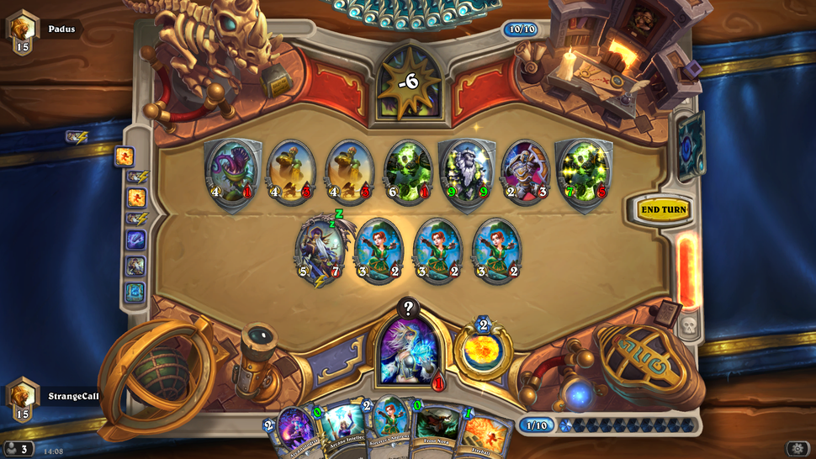

Figure1

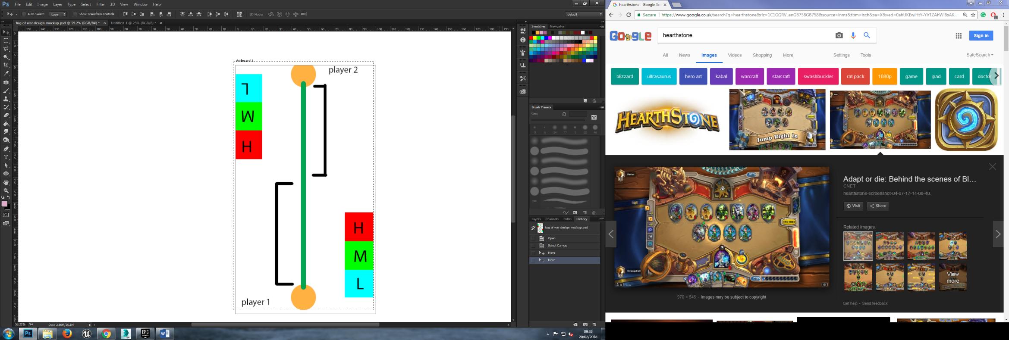As our game is based on tug-of-war (which is played synchronously), we need to find a way of giving both player equal and fair opportunity to win without it being determined by a players skill. Adding an element of chance and giving the player almost zero input into how well their avatar progresses. Tap to roll a dice and await the outcome. This will neutralise any skill required to play the game.

To create symmetry we have to give both players equal knowledge of the games mechanics and to give them equal oppurtunity to act on them. Figure 2 is a concept of how symmetry can be shown through visual design with both players having access to exactly the same information and inputs. This is what we will implement into our own game design, giving the player clear visuals as to what they can do, how this affects my chances of winning and how this affects my oppenent.

Figure 2